No Nudity Zone

One Neighbors Can See
Your Bare Ass
Nude Sun Worshiping
Clothing Optional
or Nude 24/7
Outside Picnic, Party
…and Play
Bring Your Own Towel
Pool Closes at 2:00 am
Party at Scout’s
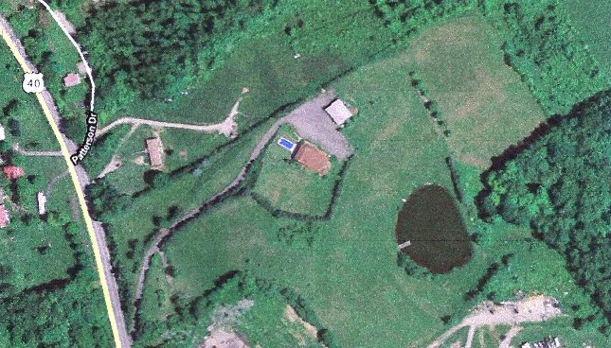

A Vacation Paradise
Yet So Close To Home

North Parking Area

Party Guest Parking

Main Parking Lot
Party Guest Parking
Hemlock
Forest
Quiet Zone
Behind the Camo
No Fucking All Night

Route 40
Historic
National Rd
East to Uniontown
Route 51
& Route 43
West to
Brownsville
Route 70
& Route 43

N

Pond
Fish All You Want

They bite without bait
Entrance
6659 National Pike East
New Salem, PA 15468

GPS Will Take You Here
Apologies. We Do Not Offer Phone Support
Smoking Deck
&
Fire Pit

Please don’t throw butts, cigars or snuff pouches in the grass.
Tent City

Fuck-All-Night-Zone

Quiet Not Required.
You Are Responsible For Your Own Trash.
It’s Our Backyard.
Please help us
keep it beautiful.

Lodge

You Can Be Nude 24/7

Quiet Time Inside
2:00 am to 9:00 am
Bathrooms/Showers

Open 24/7
No Inside Play,
Unless…
You Rent a Day-Room
Black Room/Dungeon:
$50/4 hours
Regular Party Rooms:
$50/Noon-6 pm


Orchard
Apples, Pears, Peaches

Tenting Within,
Parking on the Perimeter
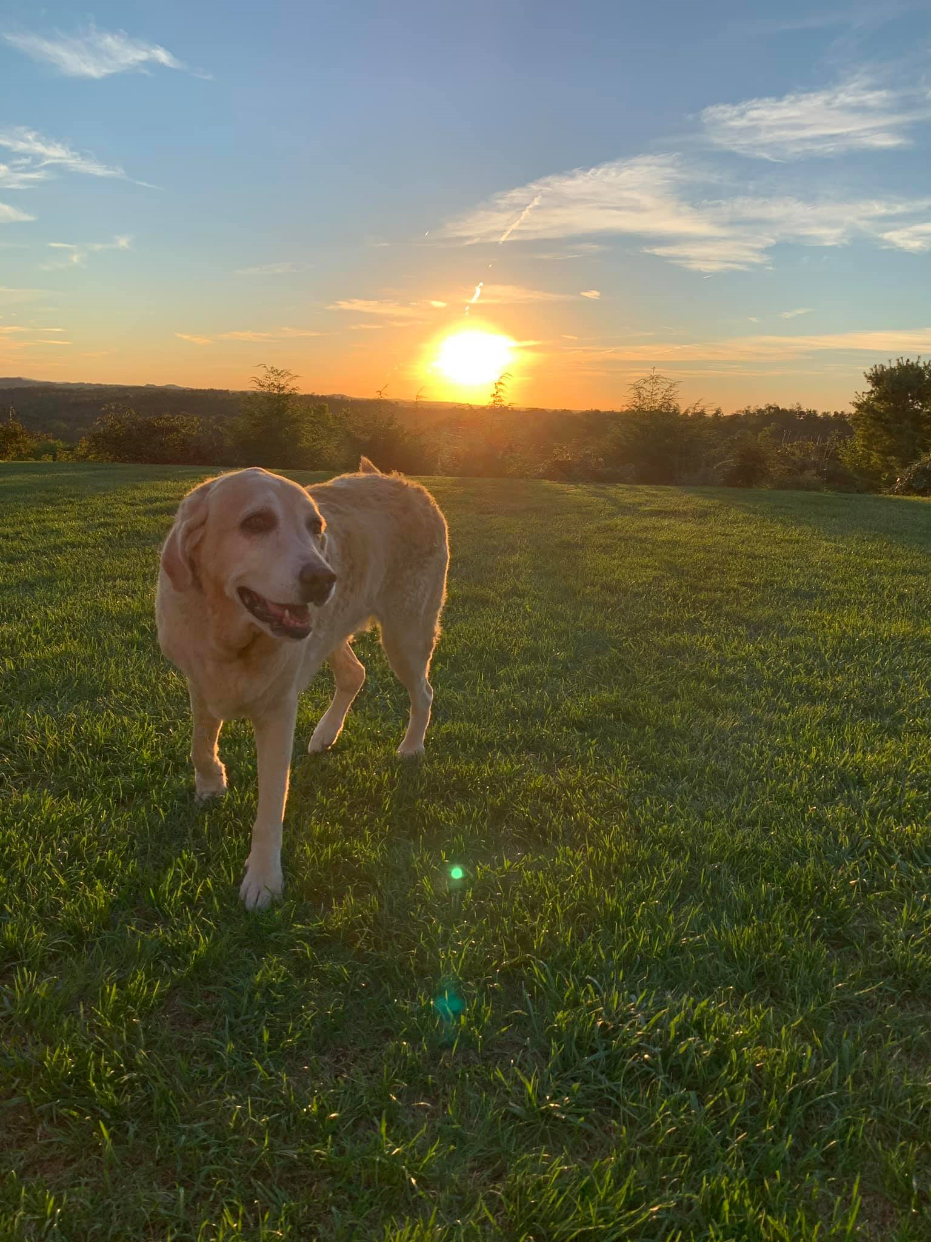
.
It’s his house
The Rest of us are just visiting

